SOFTWARE REQUIREMENT SPECIFICATIONS
(SRS)

Real time chat application
KIET GROUP OF INSTITUTIONS
Department of Computer Science
Project Guide: Dr. Ajay kumar Srivastav
DATED: 15-04-2023
Submitted By: Sachin Kushwaha (2000290120130)
SachinVerma (2000290120131)
Sidhartha Kushwaha (2100290129009)

Table of Contents
Table of Contents ii

1. Introduction 1
1.1 Purpose 1
1.2 Document Conventions 1
1.3 Intended Audience 2
1.4 Product Scope 2-3
1.5 References 3
1.6 Definitions 4
2. Overall Description 5
2.1 Product Perspective 5
2.2 Product Functions 6
2.3 User Classes and Characteristics 6-7
2.4 Operating Environment 7
2.5 Design and Implementation Constraints 7-9
2.6 User Documentation 9
2.7 Assumptions and Dependencies 9-10
3. External Interface Requirements 10
3.1 User Interfaces 10-11
3.2 Hardware Interfaces 11
3.3 Software Interfaces 11-12
3.4 Communications Interfaces 12
4. System Features 13
4.1 Functional Requirements 13-14
4.2 Use Cases 14
4.3 External Interface Requirements 15
4.4 Logical Database Requirements 15-16
4.5 Non-Functional Requirements 16

Introduction
The purpose of this document is to define the software requirements for a real-time chat application. The application will allow users to send and receive messages in real-time, as well as create and join chat rooms. The system will also include user registration and login functionality, as well as the ability to search for users and chat rooms, share files and images, and customize profile settings and preferences.

Purpose

The purpose of a real-time chat application is to provide users with a platform for instant communication and collaboration. Real-time chat applications allow users to send and receive messages in real-time, which enables them to have conversations as if they were in the same room. These applications are useful for both personal and business communication, as they provide a fast and efficient way to exchange information and ideas.

Real-time chat applications can be used for a variety of purposes, such as:

Personal communication: Real-time chat applications are a convenient way for friends and family members to stay in touch, no matter where they are located. Users can send messages, share photos and videos, and make voice or video calls, all from within the app.

Business communication: Real-time chat applications are increasingly being used in the workplace to facilitate communication and collaboration among team members. Users can send messages, share files, and collaborate on projects, all in real-time.

Customer support: Real-time chat applications can be used to provide customer support to users. Customers can chat with support representatives in real-time, enabling them to get their questions answered quickly and efficiently.

Online communities: Real-time chat applications can be used to create online communities where users can discuss shared interests, hobbies, or goals. These communities can be private or public, depending on the preferences of the users.

Document Conventions

1. Title Page: The title page should include the project name, the name of the company or organization developing the application, and the date of the document.

2. Table of Contents: The table of contents should list all the major sections and subsections of the document, along with their page numbers.

3. Introduction: The introduction should provide a brief overview of the purpose of the document, as well as a summary of the key features and functionality of the real-time chat application.

4. Scope: The scope should define the boundaries of the real-time chat application, including the features and functionality that are included and excluded from the application.

5. Requirements: The requirements section should include a detailed list of the functional and non-functional requirements for the real-time chat application. Each requirement should be clearly stated and numbered for easy reference.

6. Design: The design section should provide a detailed description of the architecture and design of the real-time chat application, including the technologies used, the data flow, and the user interface.

7. Testing: The testing section should describe the testing plan for the real-time chat application, including the testing methodology, tools, and test cases.

8. Deployment: The deployment section should describe the steps involved in deploying the real-time chat application, including the hardware and software requirements, installation procedure, and configuration settings.

9. Maintenance: The maintenance section should describe the procedures for maintaining and updating the real-time chat application, including the process for fixing bugs, adding new features, and providing technical support.

10. Glossary: The glossary should provide a list of all the technical terms and acronyms used in the document, along with their definitions.

Intended Audience
The intended audience for a real-time chat application may vary depending on the purpose and target users of the application. Here are some potential audiences for a real-time chat application:

1. Consumers: Real-time chat applications designed for personal use are intended for consumers, including individuals and families who want to communicate with friends, family members, or other contacts.

2. Businesses: Real-time chat applications designed for business use are intended for employees, managers, and other personnel who need to communicate and collaborate on projects, tasks, and other work-related activities.

3. Online Communities: Real-time chat applications designed for online communities are intended for individuals who want to connect and communicate with others who share common interests, hobbies, or goals.

4. Customer Support: Real-time chat applications designed for customer support are intended for customers who need assistance with products or services, as well as support representatives who provide assistance to customers.

5. Developers: Real-time chat applications designed for developers are intended for software developers who need to integrate chat functionality into their own applications.

6. Students: Real-time chat applications designed for educational purposes are intended for students who want to communicate with their classmates, teachers, or professors.

Product Scope
The product scope of a real-time chat application defines the boundaries of the application and specifies the features and functionality that will be included in the product. Here are some key components of the product scope for a real-time chat application:

1. Purpose: The purpose of the real-time chat application should be clearly defined. This could include the intended audience, use cases, and goals of the application.

2. Features: The product scope should include a list of the features and functionality that will be included in the application. This may include features such as sending and receiving messages, voice and video calling, file sharing, and more.

3. User Interface: The product scope should describe the user interface of the application, including the layout, design, and navigation. This may include wireframes, mockups, and other design documents.

4. Platform: The product scope should define the platforms on which the application will be developed and deployed. This may include mobile devices, desktop computers, web browsers, and more.

5. Integration: The product scope should describe any third-party integrations that will be included in the application. This may include integrations with social media platforms, payment gateways, or other third-party services.

6. Data Management: The product scope should define how user data will be stored, managed, and secured within the application. This may include data encryption, backup and recovery procedures, and other security measures.

7. Performance: The product scope should specify the performance requirements of the application, such as response times, scalability, and availability.

References
[1]. Dr. Abhay Kasetwar , Ritik Gajbhiye , Gopal Papewar , Rohan Nikhare , Priya Warade (2022),development of chat application.india.
[2] .Manish Kolambe , Saurabh Sable , Venkatesh Kashivale , Prajkta Khaire.(2022),chat application.
[3]. Uma Thakur, Abhishek Chichmalkar, Aditya Sambhare.(2022),decentralised chat applicaton,india.
[4]. Tiezer Melos, António Barros, Mário Antunes.(2021), An end-to-end cryptography based real-time chat, Leiria.

Definitions
A real-time chat application is a software application that allows users to communicate with one another in real-time using text, voice, and/or video. Here are some key definitions related to real-time chat applications:

1. Real-time: Real-time refers to the ability of the chat application to provide instant communication between users, without any significant delay.

2. Chat: Chat refers to the act of exchanging messages in real-time between users. This may include text-based chat, voice chat, or video chat.

3. Application: An application is a software program that is designed to perform a specific function or set of functions.

4. Instant messaging: Instant messaging (IM) refers to the exchange of text messages in real-time between users using a dedicated chat application.

5. Voice over Internet Protocol (VoIP): VoIP refers to the technology that allows voice communication to be transmitted over the internet using a real-time chat application.

6. Video conferencing: Video conferencing refers to the use of a real-time chat application to conduct video meetings or discussions between two or more participants in different locations.

Overall Description

Product Perspective
The product perspective of a real-time chat application defines how the application fits within its larger context, including its relationship to other products, systems, and processes. Here are some key components of the product perspective for a real-time chat application:

1. System Context: The product perspective should define the system context of the real-time chat application. This may include the systems and processes that the application interfaces with, as well as any external factors that may affect the application's performance or functionality.

2. Product Functions: The product perspective should describe the key functions of the real-time chat application, including sending and receiving messages, voice and video calling, file sharing, and more.

3. User Characteristics: The product perspective should describe the characteristics of the application's users, including their demographics, preferences, and needs. This information can help guide the design and development of the application to ensure that it meets the needs of its target audience.

4. Assumptions and Dependencies: The product perspective should identify any assumptions or dependencies that may affect the development or deployment of the real-time chat application. This may include assumptions about user behavior, technical dependencies on other systems or technologies, or assumptions about the availability of resources or personnel.

5. Product Life Cycle: The product perspective should describe the expected life cycle of the real-time chat application, including its development, testing, deployment, and ongoing maintenance and support.

Product Functions
The product functions of a real-time chat application are the key features and capabilities that enable users to communicate with each other in real-time. Here are some of the most important product functions of a real-time chat application:

1. Sending and Receiving Messages: The most basic function of a real-time chat application is to allow users to send and receive messages in real-time. This may include text messages, emojis, and other forms of multimedia content.

2. Voice and Video Calling: Many real-time chat applications also allow users to make voice and video calls in real-time. This feature may be used for one-on-one communication or group conversations.

3. File Sharing: Real-time chat applications often include a feature that allows users to share files with each other. This may include documents, images, videos, and other types of files.

4. Group Chats: Group chats are a key feature of many real-time chat applications, allowing users to communicate with multiple people at once. This feature may include the ability to create and manage groups, as well as the ability to add or remove members from a group.

5. Notifications: Real-time chat applications often include notifications that alert users when they have received a new message, missed a call, or been added to a group.

6. Emojis and Stickers: Many real-time chat applications include a wide range of emojis and stickers that users can use to express themselves and enhance their messages.

7. Status Updates: Some real-time chat applications include a feature that allows users to set a status update, indicating their availability or mood.

User Classes and Characteristics
The user classes and characteristics of a real-time chat application refer to the different types of users who will be using the application, as well as their needs and preferences. Understanding the user classes and characteristics is essential for designing an application that meets the needs of its target audience. Here are some common user classes and characteristics for a real-time chat application:

1. Individuals: Individuals are one of the primary user classes for a real-time chat application. They may use the application for personal communication with friends and family, as well as for social networking and meeting new people. Characteristics of individual users may include a desire for privacy, the need for flexibility in terms of when and where they use the application, and a preference for easy-to-use interfaces.

2. Business Professionals: Business professionals are another important user class for real-time chat applications. They may use the application for team collaboration, project management, and customer support. Characteristics of business professionals may include a need for secure and reliable communication, the ability to integrate with other business tools and software, and the need for customizable settings and permissions.

3. Students: Students are a key user class for real-time chat applications, particularly in educational settings. They may use the application for group projects, study groups, and general communication with classmates and teachers. Characteristics of student users may include a preference for a simple and intuitive interface, the ability to create and manage groups, and the ability to share files and multimedia content.

4. Non-Profits and Charities: Non-profits and charities may also use real-time chat applications for communication and collaboration. Characteristics of non-profit users may include a need for cost-effective solutions, the ability to integrate with fundraising and donor management tools, and the need for easy-to-use interfaces for volunteers and staff.

Operating Environment
The operating environment of a real-time chat application refers to the hardware and software environment in which the application will be used. It includes the operating system, network infrastructure, and other software dependencies that the application relies on to function. Here are some key components of the operating environment for a real-time chat application:

1. Operating System: The real-time chat application will need to run on a supported operating system, such as Windows, macOS, or Linux. The application should be tested and optimized for each supported operating system to ensure that it functions correctly.

2. Web Browser: If the real-time chat application is a web-based application, users will need to access it through a supported web browser, such as Google Chrome, Mozilla Firefox, or Microsoft Edge. The application should be tested and optimized for each supported web browser to ensure that it functions correctly.

3. Network Infrastructure: Real-time chat applications rely on a stable and reliable network infrastructure to function correctly. This includes the local network infrastructure (e.g. Wi-Fi network) as well as the wider internet infrastructure. The application should be designed to work with different network speeds and connection types.

4. Security Software: Real-time chat applications should be designed to work with different types of security software, such as antivirus software and firewalls. The application should not interfere with the normal operation of security software, and should be designed with security in mind to protect user data.

5. Hardware Requirements: The real-time chat application should have minimum hardware requirements that are clearly defined and communicated to users. This may include requirements for CPU speed, RAM, and disk space.

6. Software Dependencies: The real-time chat application may rely on other software dependencies, such as database software, web servers, or other libraries. These dependencies should be clearly defined and communicated to users, and the application should be designed to work with the latest versions of these dependencies.

Design and Implementation Constraints

Design and implementation are critical aspects of developing a neural style transfer system. The system should be designed and implemented with the following considerations:

ER Diagram

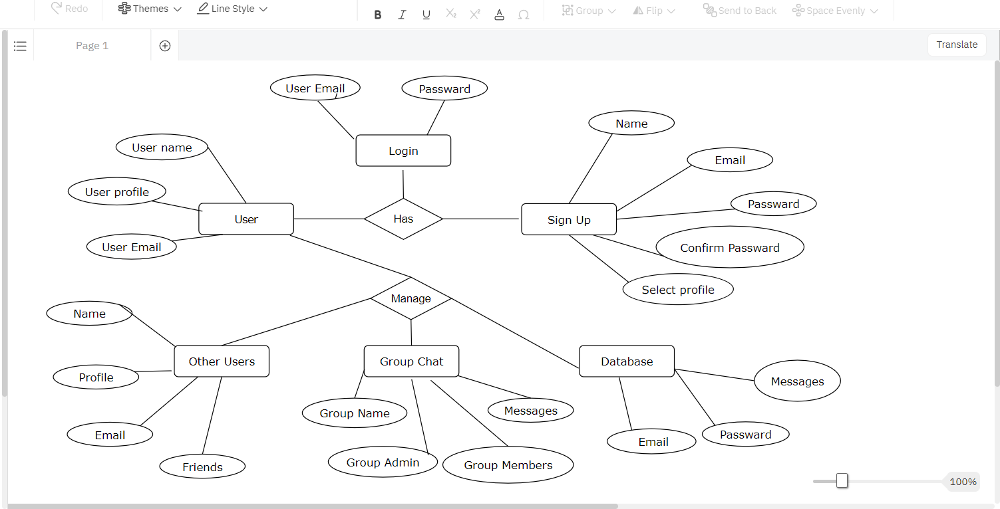

Use case Diagram
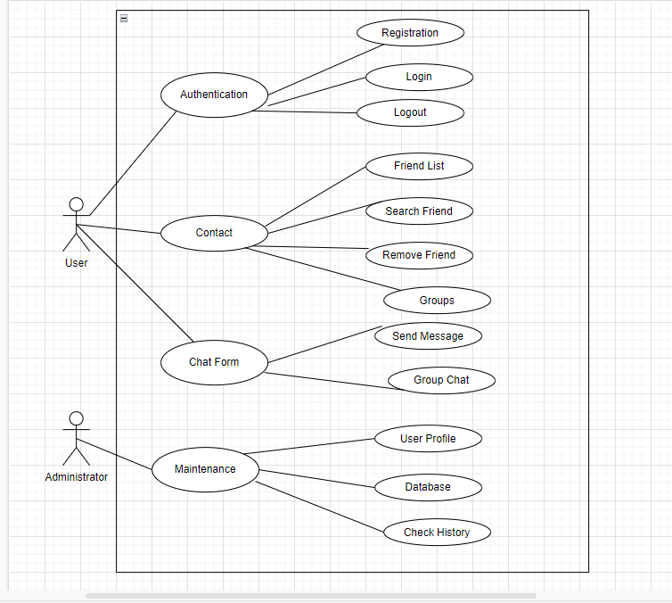

User Documentation

1. Introduction: An overview of the application and its purpose, including any key features or benefits that users should be aware of.

2. Getting Started: Step-by-step instructions on how to download, install, and set up the application. This section should include any prerequisites, such as a supported operating system or device.

3. User Interface: A description of the user interface and how to navigate the various screens and menus within the application.

4. Features: A detailed explanation of the features and functionality of the application, including how to access and use them.

5. Chatting: A guide on how to start and participate in chats, including how to send messages, create chat rooms, and join existing chat rooms.

6. Friends and Contacts: A guide on how to add friends and contacts, how to manage friend requests, and how to view contact information.

7. Settings: A guide on how to customize the application's settings, including changing the notification and privacy settings.

8. Troubleshooting: A section that provides solutions to common issues that users might encounter when using the application, along with instructions on how to contact support if further assistance is needed.

9. Glossary: A list of key terms and definitions related to the application.

Assumptions and Dependencies
Assumptions:

1. Internet Connectivity: It is assumed that users have access to a stable internet connection to use the real-time chat application.

2. Device Compatibility: It is assumed that the application is compatible with the devices being used by the users, such as desktops, laptops, or mobile devices.

3. User Behavior: It is assumed that users will use the application in a responsible and respectful manner, following any guidelines or terms of service set out by the application.

4. Security: It is assumed that the application is secure and that user data and conversations will be kept private and protected.

5. System Performance: It is assumed that the application will perform well, with no significant lag or delays in delivering messages or displaying information.

6. Technical Infrastructure: It is assumed that the necessary technical infrastructure, such as servers, databases, and network connections, are in place to support the application.

7. Availability: It is assumed that the application will be available to users for use, with minimal downtime or outages.

Dependencies:

1. Internet Connectivity: As a real-time chat application is reliant on the internet, a stable and reliable internet connection is necessary for the application to function.

2. Servers: The application needs servers to store user data, messages, and chat histories. These servers must be reliable and able to handle high levels of traffic.

3. API: Application Programming Interfaces (APIs) are often used to integrate different features or services within the chat application, such as social media login or third-party integrations.

4. Mobile Device Platforms: If the application has a mobile component, it will be dependent on the specific mobile device platforms, such as iOS or Android, and will need to be developed accordingly.

5. Database Management System: A database management system is required to store the user data, chat histories, and other relevant information. This system should be reliable and scalable, to handle the large amounts of data generated by the application.

6. Web Framework: The application needs a web framework to manage the frontend and backend development, handle user requests, and deliver responses in real-time.

7. Third-party Services: The application may rely on various third-party services, such as push notification services or cloud storage services, to function properly.

External Interface Requirements

User Interfaces
User interfaces are an essential component of any real-time chat application, as they provide users with a way to interact with the application and exchange messages in real-time. Here are some common user interfaces that might apply to a real-time chat application:

1. Chat Window: The chat window is the primary interface for exchanging messages in real-time. It should allow users to easily send and receive messages, as well as view their chat history.

2. Contact List: The contact list interface allows users to view their list of contacts and manage their chat conversations with individual contacts.

3. Profile Settings: The profile settings interface allows users to view and update their profile information, such as their profile picture, status message, and notification settings.

4. Search Interface: The search interface allows users to search for other users, chat groups, or messages within the application.

5. Group Chat Interface: The group chat interface allows users to create and manage group chat conversations, as well as add or remove group members.

6. Notification Interface: The notification interface informs users about new messages, chat requests, or other relevant notifications.

7. Login/Registration Interface: The login/registration interface allows users to create an account, log in, and manage their authentication and security settings.

Hardware Interfaces
Hardware interfaces for a real-time chat application refer to the physical components and devices that are required to support the application. Here are some common hardware interfaces that might apply to a real-time chat application:

1. Server Hardware: The server hardware interface includes the physical servers, storage devices, and networking equipment required to support the application's backend infrastructure.

2. Mobile Devices: The mobile device interface includes smartphones, tablets, and other mobile devices that are used to access the application.

3. Desktop Computers: The desktop computer interface includes laptops, desktop computers, and other computing devices that are used to access the application.

4. Cameras and Microphones: Cameras and microphones may be used to support video and voice chat functionality within the application.

5. Speakers and Headphones: Speakers and headphones may be used to support audio chat functionality within the application.

6. Bluetooth and Other Wireless Interfaces: Bluetooth and other wireless interfaces may be used to support connectivity between the application and other devices, such as wearable technology.

7. Cloud Infrastructure: Cloud infrastructure providers, such as Amazon Web Services or Microsoft Azure, may be used to support the application's backend infrastructure and provide scalability and reliability.

Software Interfaces
Software interfaces are an essential component of any real-time chat application, as they provide a way for the application to communicate with other software components and systems. Here are some common software interfaces that might apply to a real-time chat application:

1. Operating System: The application may need to interface with the operating system of the user's device, to access system resources such as memory, storage, and network connectivity.

2. Web Browsers: The application may need to interface with different web browsers, to ensure that the user interface is compatible across different platforms and devices.

3. Web Servers: The application may need to interface with web servers, to manage and process user requests and provide real-time messaging functionality.

4. Database Systems: The application may need to interface with database systems, to store and manage user data, chat histories, and other relevant information.

5. Third-Party APIs: The application may need to interface with third-party APIs, to provide additional functionality such as authentication, location-based services, or multimedia sharing.

6. Messaging Protocols: The application may need to interface with messaging protocols such as XMPP (Extensible Messaging and Presence Protocol), to ensure reliable and secure message exchange between users.

7. Development Tools and Frameworks: The application may need to interface with development tools and frameworks, to support software development and testing.

Communications Interfaces
Communications interfaces for a real-time chat application refer to the protocols and standards used to enable communication between different components and systems. Here are some common communication interfaces that might apply to a real-time chat application:

1. Transmission Control Protocol/Internet Protocol (TCP/IP): TCP/IP is a standard protocol used to transmit data over the internet, and it is commonly used in real-time chat applications.

2. Hypertext Transfer Protocol (HTTP): HTTP is a protocol used to transfer data over the web, and it is commonly used in web-based chat applications.

3. WebSocket: WebSocket is a protocol that enables bi-directional communication between a server and a client, and it is commonly used in real-time chat applications to support messaging functionality.

4. Simple Mail Transfer Protocol (SMTP): SMTP is a protocol used to transmit email messages over the internet, and it may be used in chat applications that support email notifications or alerts.

5. Extensible Messaging and Presence Protocol (XMPP): XMPP is an open standard protocol used for instant messaging and presence information, and it may be used in real-time chat applications to support messaging functionality.

6. Real-Time Transport Protocol (RTP): RTP is a protocol used for real-time transmission of audio and video over the internet, and it may be used in chat applications that support video or voice chat functionality.

These communication interfaces must be carefully managed and optimized to ensure that they can support the real-time messaging functionality of the application and provide a seamless user experience. Additionally, the communication interfaces should be designed to provide sufficient scalability and reliability, to ensure that the application can handle large volumes of users and messages.

System Features

Here are some typical system features of a real-time chat application:

1. User registration and authentication: This feature allows users to create an account and log in to the application, providing secure access to their chats and user data.

2. Real-time messaging: The core feature of the application is the ability for users to send and receive messages in real-time. This may include support for text, images, files, voice or video messages.

3. Chat history and search: The application should store and allow users to search through their chat history, including the ability to filter messages by date or user.

4. Presence and status indicators: Users should be able to see the online/offline status of their contacts, as well as their current activity or availability status.

5. Group chats and channels: The application should support group chats and channels, which allow users to communicate with multiple users at once.

6. Notifications: The application should provide notifications to users for new messages, mentions, or other relevant activity.

7. Contact management: Users should be able to manage their contacts and create groups or lists of contacts for easier communication.

8. Privacy and security: The application should provide privacy and security features, such as end-to-end encryption, user blocking, or message deletion.

9. Customization: Users should be able to customize the application with different themes, backgrounds, or emojis.

10. Cross-platform support: The application should be able to work seamlessly across different devices and platforms, such as mobile devices, desktops, or web browsers.

These system features should be carefully designed and optimized to ensure that they can support the real-time messaging functionality of the application and provide a seamless user experience. Additionally, the system features should be scalable and reliable, to ensure that the application can handle large volumes of users and messages.

4.1 Functional Requirements:

Here are some common functional requirements for a real-time chat application:

1. User Authentication and Authorization: The chat application should have a secure authentication mechanism that allows users to log in or register securely. It should also support different roles and permissions for users, such as admin, moderator, and regular user.

2. Real-time Messaging: The core functionality of a chat application is to allow users to send and receive messages in real-time. The application should support real-time messaging using websockets or a similar technology that enables fast and efficient communication between clients and the server.

3. Group Chats: The application should allow users to create groups and invite other users to join the group. It should also support the ability to leave groups and remove members from groups.

4. One-on-one Chats: Users should be able to start a private conversation with another user. The application should also support the ability to block or report users if necessary.

5. Message Status: Users should be able to see the status of their messages, such as whether they have been delivered or read by the recipient.

6. Notifications: The application should notify users of new messages and other important events, such as when they are invited to a group or when they receive a friend request.

7. Emojis and Stickers: Users should be able to express themselves using emojis and stickers in their messages.

8. File Sharing: Users should be able to share files such as images, videos, and documents with other users in the chat.

9. Search: The application should provide a search functionality that allows users to search for messages, groups, or other users.

10. Profile Management: Users should be able to edit their profile information, such as their name, profile picture, and status message. The application should also allow users to view other users' profiles.

4.2 Use Cases:

Use cases are descriptions of how a user interacts with a system to achieve a specific goal. In the context of a neural style transfer system, some example use cases may include:

Apply style to an image: The user uploads an image and selects a style from a library of pre-defined styles or uploads their own style image. They adjust the style transfer parameters to their liking and preview the results before applying the changes.

Batch process multiple images: The user selects a set of images and applies the same style to each image in a batch process. They can preview the results and download the processed images.

Crop and resize images: The user can perform basic image processing tasks such as cropping and resizing within the neural style transfer system before applying the style transfer process.

Apply filters to images: The user can apply various image filters to the input and output images to enhance the visual quality.

Integrate with other systems: The user can integrate the neural style transfer system with other systems and platforms, such as content management systems, e-commerce platforms, and social media platforms, to enhance the user experience.

Manage user profile: The user can manage their profile and preferences within the neural style transfer system, such as updating their personal information, viewing their processing history, and setting notification preferences.

Apply style to video: The user uploads a video and applies the selected style to each frame of the video. They can preview the results and download the processed video.

Each use case represents a specific scenario in which a user interacts with the neural style transfer system to achieve a goal. It is important to identify and prioritize the use cases to ensure that the system meets the needs of its users.

4.3 External Interface Requirements:

1. User Interface: The application should have a user-friendly interface that is easy to navigate and understand. The interface should support different screen sizes and be accessible on multiple platforms, such as web, desktop, and mobile.

2. APIs: The application should expose APIs to allow third-party developers to integrate the chat functionality into their applications. The APIs should be well-documented and easy to use.

3. Push Notifications: The application should integrate with the device's notification system to send push notifications to users when they receive new messages or other events.

4. Authentication and Authorization: The application should integrate with popular authentication and authorization providers, such as OAuth or OpenID, to allow users to log in securely.

5. File Storage: The application should integrate with cloud storage providers, such as Amazon S3 or Google Cloud Storage, to store and retrieve files that are shared in chats.

6. Payment Gateways: If the application charges for premium features or subscription plans, it should integrate with popular payment gateways, such as PayPal or Stripe, to process payments securely.

7. Analytics: The application should integrate with analytics providers, such as Google Analytics or Mixpanel, to track user behavior and measure the application's performance.

8. Social Media Integration: The application should allow users to share messages and other content on social media platforms, such as Facebook or Twitter, to increase the application's visibility and reach.

9. Localization: The application should support multiple languages and integrate with translation services, such as Google Translate or Microsoft Translator, to provide a seamless user experience for users who speak different languages.

10. Accessibility: The application should be designed with accessibility in mind and conform to accessibility guidelines, such as WCAG 2.1, to ensure that users with disabilities can use the application without any difficulties.

4.4 Logical Database Requirements:

1. User Profile: The application should have a user profile database that stores user information such as name, email, username, password, and profile picture. This database should also store additional user metadata such as login history, user settings, and preferences.

2. Messages: The application should have a messages database that stores all messages sent and received by users. This database should include message content, timestamp, sender, recipient, and message status.

3. Groups: The application should have a group database that stores information about groups, such as the name, description, members, and administrators. This database should also store additional group metadata such as creation date, last activity date, and group settings.

4. User Relationships: The application should have a user relationships database that stores information about the relationships between users, such as friends, blocked users, and reported users.

5. Notifications: The application should have a notifications database that stores information about notifications, such as the type, recipient, content, and status. This database should also include metadata such as the timestamp and notification settings.

6. File Storage: The application should have a file storage database that stores files that are shared in chats, such as images, videos, and documents. This database should include file metadata such as the filename, file size, and content type.

7. Analytics: The application should have an analytics database that stores information about user behavior, such as the number of messages sent and received, user engagement, and other metrics. This database should also include metadata such as the timestamp and location.

8. User Activity: The application should have a user activity database that stores information about user activity, such as login history, logout history, and other user-related activities.

9. Support Tickets: The application should have a support tickets database that stores information about user support requests, such as the type of request, the user who submitted the request, the status of the request, and any notes or comments related to the request.

10. Security Logs: The application should have a security logs database that stores information about security-related events, such as failed login attempts, successful login attempts, and other security events. This database should include metadata such as the timestamp, IP address, and user agent.

4.5 Non-functional Requirements:

Non-functional requirements are the system requirements that specify how the system should perform, rather than what it should do. They describe the overall characteristics of the system and the constraints within which it operates.

Here are some common non-functional requirements for a real-time chat application:

1. Performance: The application should have high performance and be able to handle a large number of concurrent users and messages without any performance degradation. The application should also have low latency and fast response times.

2. Scalability: The application should be scalable and able to handle an increasing number of users and messages without any impact on performance.

3. Availability: The application should be highly available and able to handle user requests without any downtime. The application should also have a disaster recovery plan in place to ensure availability in case of any unexpected failure.

4. Reliability: The application should be reliable and able to deliver messages to users without any loss or delay. The application should also have a backup and recovery plan in place to ensure data integrity in case of any unexpected failure.

5. Security: The application should be secure and able to protect user data and messages from unauthorized access or interception. The application should also comply with data protection regulations, such as GDPR or CCPA.

6. Usability: The application should be easy to use and intuitive, with a user-friendly interface that is accessible on multiple platforms and devices.

7. Compatibility: The application should be compatible with multiple devices and operating systems, such as Windows, Mac, iOS, and Android.

8. Interoperability: The application should be interoperable with other messaging platforms and able to send and receive messages from other platforms using industry-standard protocols.

9. Maintainability: The application should be easy to maintain and update, with a modular design that allows for easy component replacement or upgrades.

10. Cost: The application should be cost-effective and efficient, with a low cost of ownership and minimal hardware and software requirements.

